FORMAT FOR LABORATORY REPORTS
- The report should be prepared on computer
- The type kind should be Times New Roman and the type size should be 12.
- The text should be justified between margins and line spacing should be 1
- Table titles, figure heads and references should be written with line spacing of 1.
- The type size in the tables and figures could be between sizes of 8 and 12.
- Tables and figures should be centered horizontally. If they are smaller than 1 page, they should be placed the top or bottom part of the page with two line spacing between nearest main text and the figure.
- Smaller type size than that of main text should be used for subscript and superscripts.
- The section headings should be written in bold uppercase characters aligned to the left margin. There should be two line spacing after the heading.
- Subsection headings should be separated from the main text with one line spacing. They should be written in bold characters aligned to the left margin, and first character of each word should be capitalized.
- Tables and figures should be numbered with respect to the section numbers. An example for each ban be found on the following.
- Use a consistent citation style throughout the report.

Table 1. The change of volumetric flow rate with respect to time in the experiment
Time  [s] | Volumetric Flow Rate  [m³/s]
5 | 0.10
10 | 0.20
15 | 0.26
20 | 0.28
25 | 0.29
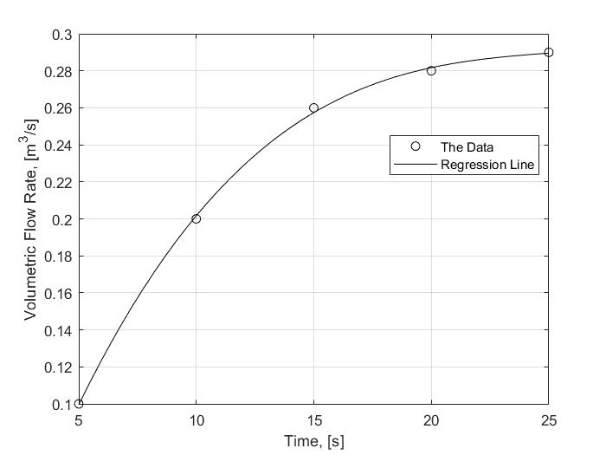

Figure 1. Volumetric flow rate measurements in the experiment and third-degree polynomial regression line.

