ENE 320 – 411
LABORATORY REPORT TEMPLATE
THE FORMAT
- The report should be prepared on computer
- Left side margin should be 3.5 cm, other three margins should be 2.5 cm.
- The type kind should be Times New Roman and the type size should be 12.
- The text should be distributed evenly between margins and line spacing should be 1.5
- Table titles, figure heads and references should be written with line spacing of 1.
- The type size in the tables and figures could be between sizes of 8 and 12.
- Tables and figures should be centered horizontally. If they are smaller than 1 page, they should be placed the top or bottom part of the page with two line spacing between nearest main text and the figure.
- Smaller type size than that of main text should be used for subscript and superscripts.
- The section headings should be written in bold uppercase characters aligned to the left margin. There should be two line spacing after the heading.
- Subsection headings should be separated from the main text with one line spacing. They should be written in bold characters aligned to the left margin, and first character of each word should be capitalized.
- Paragraph should begin with 1 cm indentation.
- Tables and figures should be numbered with respect to the section numbers. An example for each ban be found on the following.
- Use a consistent citation style throughout the report.

Table 1.1. The change of volumetric flow rate with respect to time in the experiment
Time  [s] | Volumetric Flow Rate  [m³/s]
5 | 0.10
10 | 0.20
15 | 0.26
20 | 0.28
25 | 0.29
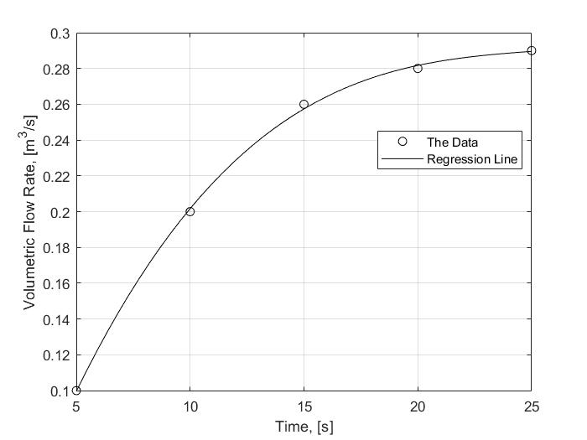

Figure 1.1. Volumetric flow rate measurements in the experiment and third-degree polynomial regression line.

The report should include the following sections. Please pay attention to the explanations provided for each section.
TITLE PAGE
Title page should include course code and course name, experiment name, participants, and submission date

objective
In this section, you should state the objective the experiment in a few sentences.

DATA SHEET
You should provide data sheet you have documented and any additional data taken during the experiment in a tabulated form. (Form the table from scratch, do not use scanned pages!)

SAMPLE CALCULATIONS
This section should include your sample calculations for the results. Write your steps clearly using proper equation editing tools (i.e. MC Word built-in equations or LaTeX). If you have to calculate similar steps multiple times, write only one sample calculation. Make sure you explain the steps.

RESULTS IN TABULAR FORM
This section should include your results as a table. If results table is provided in the experiment manual, you may use it. If not, you should express your results in a clear manner. If any graph or figure is requested, put them in this section.

DISCUSSION
In this section, you should state the results of the experiment briefly. Then, you should make a solid discussion about the experiment and results. Make sure you refer to every figure or table you have put in the section 4. Discuss possible discrepancies in the results and provide reasonings for errors if applicable. Note that there may be some specific discussions mentioned in the experiment manual, make sure you mention them in this section.

REFERENCES
Use the IEEE format for the references. Make sure any reference you have used is properly cited in the main text.

